BHARATI VIDYAPEETH’S COLLEGE OF ENGINEERING FOR WOMEN

FDP ON

“RESEARCH OPPORTUNITIES IN SUSTAINABLE DEVELOPMENT USING GIS TECHNOLOGIES”

SPONSORED BY AICTE TRAINING AND LEARNING (ATAL) ACADEMY

11 NOVEMBER 2024

Report on Industry Visit

Location: Maharashtra Remote Sensing Application Centre, Pune.

Resource Person: Dr.Sanjay Patil
Sr. Scientist,MASAC, Pune
Date: 14/11/2024
Dr. Sanjay Patil delivered an insightful and engaging explanation of the GIS and remote sensing processes, making the session extremely valuable. MRSAC collaborates closely with the Planning Department of the Government of Maharashtra and has expanded by setting up additional centers in Mumbai (2013) and Pune (2014), ensuring the smooth execution and timely decision-making for state projects. In addition, MRSAC offers soft skills training and capacity-building programs to government officials, administrators, NGOs, and university students. By leveraging advanced technologies and a comprehensive digital database across multiple themes, MRSAC is committed to empowering the state with vital scientific resources. As a leading center in Natural Resource Monitoring and GIS, MRSAC continues to uphold its dedication to fostering a more transparent, dynamic, and effective e-governance framework for Maharashtra’s progress.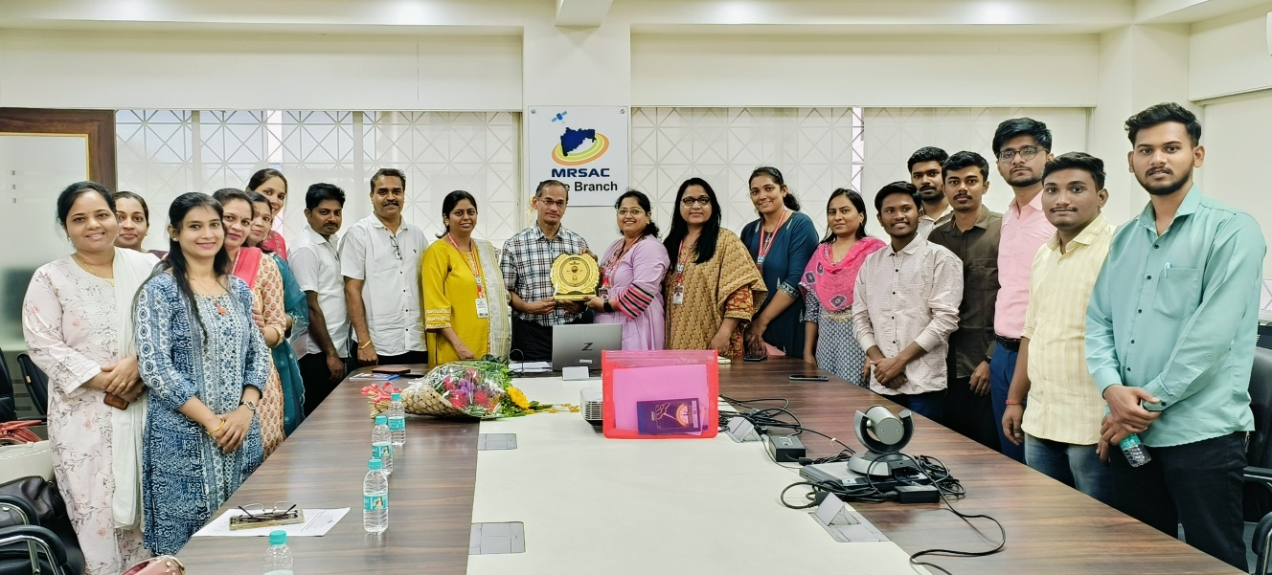
Photo: Industry Visit at MASAC,Pune.
Prepared By
Dr. Prakash Vishnu Pise

